**UNIVERSITY OF RWANDA**

**CBE GIKONDO CAMPUS**

**YEAR 2**

**DEPARTMENT OF BUSINESS AND INFORMATION TECHNOLOGY**

**NAMES: UMUCYO LILIAN**

**REG NUMBER: 221022371**

**QUIZ OF JAVA**

According to what you have told us to do, I have started with **JAVA CONTROL STATEMENT AS A TOPIC.** And I have done 3 experiments on control statement.

### First experiment: 1) Simple if statement:

**SOURCE CODE ARE THE FOLLOWING:**

**class Student // class name**

**{**

**public static void main(String[] args) //main method**

**{**

**int a = 10; //variable a which stores the value of 10**

**int b = 12; //variable b which stores the value of 12**

**if(a+b > 20) //test condition**

**{**

**System.out.println("a + b is greater than 20");**

**}**

**}**

**}**

**OUTPUT OF THE ABOVE SOURCE CODES IS THE FOLLOWING:**

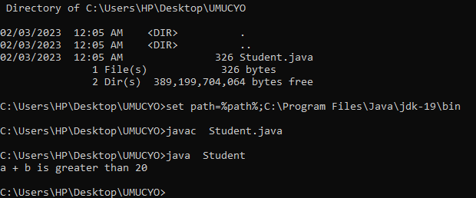

### SECOND EXPERIMENT: 2) if-else statement

**SOURCE CODES ON IF-ELSE STATEMENT ARE THE FOLLOWING:**

class LILY //class name

{

public static void main(String[] args) //main method

{

int c = 22; //variable c which stores the value of 22

int d = 11; //variable d which stores the value of 11

if(c+d < 10) //test condition

{

System.out.println("c + d is less than 10"); //statement 1

}

else

{

System.out.println("c + d is greater than 20"); //statement 2

}

}

}

**OUTPUT OF THE ABOVE SOURCE CODES ARE THE FOLLOWING:**

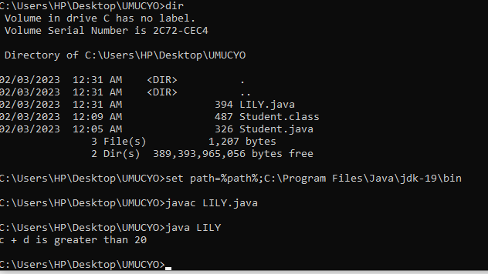

### THIRD EXPERIMENT: Java for loop

**SOURCE CODES ON JAVA FOR LOOP ARE THE FOLLOWING:**

class BIT //class name

{

public static void main(String[] args) //main method

{

int add = 0;

for(int i = 1; i<=10; i++) // for loop

{

add = add + i;

}

System.out.println("The sum of first 10 natural numbers is " + add); //statement

}

}

**OUTPUT OF THE ABOVE SOURCE CODES IS THE FOLLOWING:**

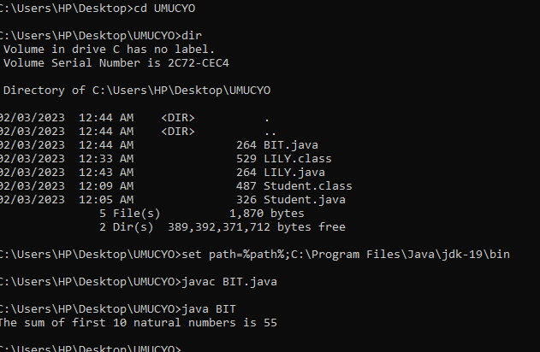

Second topic : **JAVA OBJECT AND CLASS**

### FIRST EXPERIMENT ON SECOND TOPIC: Object and Class Example: main within the class

**SOURCE CODES OF FIRST EXPERIMENT ARE THE FOLLOWING:**

class NAME // name of the class

{

int id; // data type and variable

String name; // data type and variable

public static void main(String args[]) // main method

{

NAME ob=new NAME();//creating an object which will help to access data members of the class

System.out.println(ob.id); //accessing member through reference variable

System.out.println(ob.name);

}

}

**OUTPUT OF THE ABOVE SOURCE CODE IS THE FOLLOWING:**

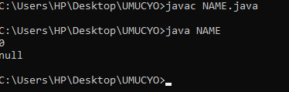

### SECOND EXPERIMENT: Object and Class Example: main outside the class

**SOURCE CODES ON SECOND EXPERIMENT ARE THE FOLLOWING:**

class Student

{

int id;

String name;

}

//Creating another class TestStudent1 which contains the main method

class TestStudent1{

public static void main(String args[]){

Student s1=new Student();

System.out.println(s1.id);

System.out.println(s1.name);

}

}

**OUTPUT OF THE ABOVE SOURCE CODES IS THE FOLLOWING:**

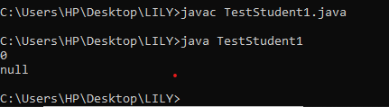

### THIRD EXPERIMEMT:  Object and Class Example: Initialization through reference

**SOURCE CODES ON THIRD EXPERIMENT ARE THE FOLLOWIMG:**

**class Student //class name**

**{**

**int id; //variable one is id**

**String name; // variable 2 is name**

**}**

**class TestStudent2**

**{**

**public static void main(String args[]) // main method**

**{**

**Student s1=new Student(); //object S1 which will help to access data members of the class**

**s1.id=101;**

**s1.name="Sonoo";**

**System.out.println(s1.id+" "+s1.name);// statement which will help to print members with a white space**

**}**

**}**

**OUTPUT OF THE ABOVE SOURCE CODE IS THE FOLLOWING:**

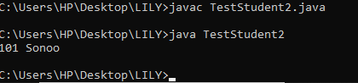

THIRD TOPIC**: INHERITANCE**

**SOURCE CODES ON SINGLE INHERITANCE ARE THE FOLLOWING:**

class A

{

void eat()

{

System.out.println("eating...");

}

}

class Dog extends A

{

void bark()

{

System.out.println("barking...");

}

}

class TestInheritance

{

public static void main(String args[])

{

Dog OBJECT=new Dog();

OBJECT.bark();

OBJECT.eat();

}

}

OUTPUT OF THE ABOVE SOURCE CODE IS THE FOLLOWING:

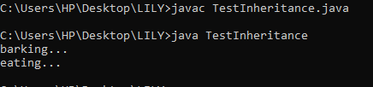

## SECOND EXPERIMENT: **Multilevel Inheritance Example**

**SOURCE CODES ON MULTILEVEL INHERITANCE ARE THE FOLLOWING:**

class Animal //class name

{

void eat()

{

System.out.println("eating...");

}

}

class Dog extends Animal

{

void bark()

{

System.out.println("barking..."); //statement

}

}

class BabyDog extends Dog

{

void weep()

{

System.out.println("weeping...");

}

}

class TestInheritance2 //class name

{

public static void main(String args[]) //main method

{

BabyDog d=new BabyDog(); //object d which will help to access data members and member function of the class

d.weep();

d.bark();

d.eat();

}

**}**

**OUTPUT OF THE ABOVE SOURCE CODE IS THE FOLLOWING:**

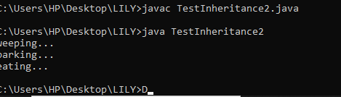

THIRD EXPERIMENT: HIERARCHICAL INHERITANCE

**SOURCE CODES ON HIERARCHICAL INHERITANCE IS THE FOLLOWING:**

class Animal{

void eat(){System.out.println("eating...");}

}

class Dog extends Animal{

void bark(){System.out.println("barking...");}

}

class Cat extends Animal{

void meow(){System.out.println("meowing...");}

}

class KESSY{

public static void main(String args[]){

Cat c=new Cat();

c.meow();

c.eat();

//c.bark();//C.T.Error

}}

**OUTPUT OF THE ABOVE SOURCE CODES IS THE FOLLOWING:**

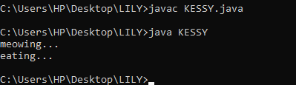

FORTH TOPIC: POLYMORPHISM

### FIRST EXPERIMENT:  method overriding

### SOURCE CODES ARE THE FOLLOWING:

### class Vehicle

### {

### void run()

### {

### System.out.println("Vehicle is running");

### }

### }

### //Creating a child class

### class Bike extends Vehicle

### {

### public static void main(String args[])

### {

### //creating an instance of child class

### Bike obj = new Bike();

### //calling the method with child class instance

### obj.run();

### }

### }

### OUTPUT OF THE ABOVE SOURCE CODE IS THE FOLOWING:

### 

### SECOND EXPERIMENT: Example of method overriding

### SOURCE CODES ARE THE FOLLOWING:

### class Vehicle{

### //defining a method

### void run(){System.out.println("Vehicle is running");}

### }

### //Creating a child class

### class Bike2 extends Vehicle{

### //defining the same method as in the parent class

### void run(){System.out.println("Bike is running safely");}

### 

### public static void main(String args[]){

### Bike2 obj = new Bike2();//creating object

### obj.run();//calling method

### }

### }

OUTPUT OF THE ABOVE SOURCE CODES IS THE FOLLOWING:

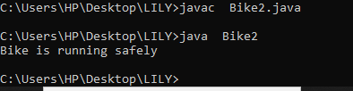

THIRD EXPERIMENT:

SOURCE CODES ARE THE FOLLOWING:

class Bank{

int getRateOfInterest(){return 0;}

}

//Creating child classes.

class SBI extends Bank{

int getRateOfInterest(){return 8;}

}

class ICICI extends Bank{

int getRateOfInterest(){return 7;}

}

class AXIS extends Bank{

int getRateOfInterest(){return 9;}

}

//Test class to create objects and call the methods

class Test2{

public static void main(String args[]){

SBI s=new SBI();

ICICI i=new ICICI();

AXIS a=new AXIS();

System.out.println("SBI Rate of Interest: "+s.getRateOfInterest());

System.out.println("ICICI Rate of Interest: "+i.getRateOfInterest());

System.out.println("AXIS Rate of Interest: "+a.getRateOfInterest());

}

}

OUTPUT **OF** THE ABOVE SOURCE CODE IS THE FOLLOWING:

